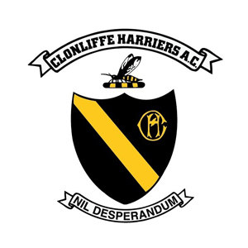

CLONLIFFE HARRIERS A.C.

RETURN TO TRAINING

PHASE 2 – COMMENCING JUNE 8TH

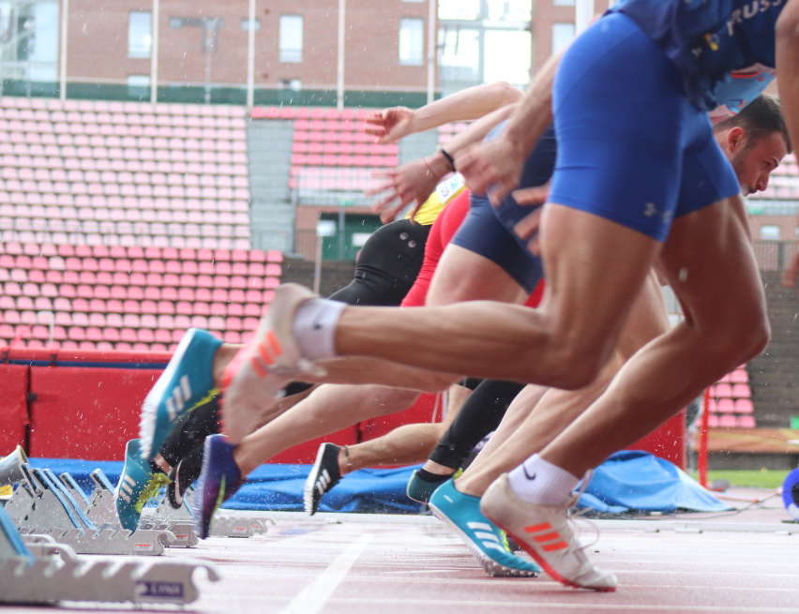
Covid-19 Safety Officer: Noel Guiden

Covid-19 Assistant Safety Officers: Stephen Bateson, Gerry Cullen

- Club access

- Access is restricted to members of Clonliffe Harriers

- Athletes must be in excess of U/13 and the upper age limit is 70 years.

- U/18 athletes must be accompanied by a parent/guardian. In order to assist with social distancing, parents/guardians are requested to remain in their vehicle or leave the stadium grounds until the athlete is finished their session. If the athlete has run to the stadium as part of their warmup and is running home then this does not apply.

- You cannot attend if you have been out of the country in the preceding fourteen days.

- You cannot attend if you have been in contact with someone with symptoms of Covid-19 in the previous 14 days.

- You cannot attend if you are in a period of self isolation or cocooning under current health policy.

- You cannot attend if you are displaying Covid-19 symptoms (fever +38 degrees, cough, sore throat, shortness of breath, flu like symptoms).

- You can attend Morton Stadium if you are within 20 km or within the county of Dublin.

- You cannot attend if a member of your household is self-isolating, as per HSE guidelines you must follow restrictive movements and, therefore, stay away from training.

- Phase 2 as announced by An Taoiseach on the 5th of June, provides for groups of up to fifteen individuals may meet to engage in outdoor sporting activity (Note – this fifteen individuals includes coaches).

- Bookings

Coaches must make a booking for their group. Please note that in Phase 2 it is restricted to a maximum of fifteen, to include the coaches. Please, therefore, restrict your group on each session in Morton Stadium to a maximum of fifteen (including coaches). If you have a group that exceeds this total number please spread the group to both Tuesday and Thursday.

Club members who are not a member of a particular coaching group can make a booking for the time, which is allocated from 8.30 to 9.00 p.m. This has to be restricted to a maximum of 20.

All, either coaches or individuals, therefore, must follow the following procedure to confirm the booking of their slot.

You must confirm/book by email in advance bookingsclonliffeharriersac@gmail.com.

Please format your booking email as follows:

Name of person making booking – day and date – time.

Lead coach – name – telephone – email

Second coach – name – telephone – email

Name of athletes taking part – telephone – email (this is required in respect of every athlete taking part in the session

PLEASE NOTE THAT THIS IS VITALLY IMPORTANT AS IT IS TO BE RETAINED BY THE CLUB FOR CONTACT TRACING BY THE RELEVANT AUTHORITIES IF NEEDED.

PLEASE ALSO NOTE, THEREFORE, THAT ANY CHANGES MUST BE NOTIFIED IN ADVANCE.

PLEASE ALSO NOTE THAT IF A MEMBER OF THE GROUP DOES NOT ATTEND TRAINING YOU MUST NOTIFY AGAIN BE EMAIL THE FOLLOWING DAY THAT THAT PERSON DID NOT ATTEND.

IT IS VITALLY IMPORTANT THAT WE HAVE FULL AND ACCURATE RECORDS FROM THE OFF

IMPORTANT: NO MEMBER OF THE GROUP INCLUDING COACHES ARE PERMITTED TO ATTEND UNDER THE GUIDELINES IF:

- They have within the previous fourteen days been diagnosed as positive for Covid-19.

- Within the last fourteen days have been in close proximity with an individual who has tested positive for Covid-19.

- Are displaying symptoms of Covid-19.

- Have within the last fourteen days visited any country outside of the island of Ireland.

- Have been advised by a doctor to self-isolate at this time.

- Have been advised by a doctor to cocoon at this time.

- Track/Field allocated training slots

To utilise the track as fully as possible the following are the allocated slots to each training group:

Tuesdays and Thursdays:

7.00 to 7.30 p.m. Philip O’Doherty group/Eugene Coppinger group/
Maurice Ahern group (Lanes 1 – 4)

7.00 to 7.30 p.m. Gerry Carr Sprints group (Lanes 6 – 10)

7.30 to 8.00 p.m. Gerry Carr Sprints group (Lanes 6 – 10)

7.30 to 8.00 p.m. Peter McDermott group/Joe Cooper group/
Pamela Cooper group (Lanes 1 – 4)

8.00 to 8.30 p.m. Mick Fogarty group/Noel Guiden group (Lanes 1 - 3)

8.00 to 9.00 p.m. John Shields group/Ciaran Donohue (Lanes 6 – 10)

8.30 to 9.00 p.m. Individual club members – booking required (Lanes 1 – 3)

Field Eventers:

7.00 to 8.00 p.m. Throws in outside cage

7.00 to 8.00 p.m. (Infield) – Javelin

8.00 to 9.00 p.m. Jumps (High Jump, Pole Vault, Long Jump)

Sundays

9.30 to 11.00 a.m. Middle distance group (Lanes 1 – 3)
Sprints groups (John Shields and Gerry Carr) (Lanes 5 – 10)

10.00 to 10.30 a.m. Ditto

10.30 to 11.00 a.m. Ditto

Notes:

Lanes 4 and, on occasions 4 and 5 will be ‘no man’s land’.

No warmups on the track.

Middle distance etc. – all warmups to be done off site – Please notify your athletes to strictly observe social distancing whilst warming up.

Athletes then on the track must observe social distancing during all training.

All athletes to bring their own equipment with them – no sharing of water bottles, no sharing of equipment. If athletes must use equipment, for example long jumpers needing to use rakes, you must bring some kind of sanitation wipes with you to wipe down any equipment before you use and to wipe down after you use. Long jumpers to replace the covering on the long jump after use.

- Arrival at stadium

Please ensure that your athletes are aware of the session they are doing before they come onto the track. For athletes who are doing their warmup they should time matters to arrive at the stadium to commence their sessions five minutes before their booked session as per Athletics Ireland guidelines.

Please also ensure that your athletes are aware that they have to warm up themselves upon arrival rather than having a group congregating together. Groups should be dissuaded from congregating and should be encouraged to go and do their own warmup.

Athletes must not car share and must make their own way to the stadium in their cars if using or if possible should run to the stadium as their warmup.

Athletes should arrive ready to train – please note there will be no dressing room facilities.

Please further note that the clubhouse is closed.

Please note there may be limited toilet facilities over at the main stadium side – there will be strict protocols in operation which have to be observed.

Athletes should sanitise their hands upon arrival at the stadium.

Athletes must be absolutely vigilant with water bottles so there is no touching of water bottles against another water bottle – it is suggested that athletes should bring their water bottle in a spike bag and keep it in their own spike bag at all times.

- Access to Track/Field

Access to the track is either via the gate at the Clonliffe clubhouse or the gate at the main entranceway (the finish area). Please use these gates only.

When leaving the track use the gate the 1500 start/long jump area only.

- Track athletes

Social distancing must be maintained at all times (all to be 2 meters apart).

Groups of three working with one coach only – if there are two coaches with a group with three athletes each subgroup must go to different area in the stadium.

During the course of the rep a two meter gap must be maintained by all members of the group at all times.

Once the rep is finished and the group steps off the track social distancing (2 meters apart) must be maintained by all members of the group before getting back on the track for the following rep.

- Field event athletes

Physical distancing to be observed throughout the course of the period.

No equipment should be exchanged between athletes.

If stadium equipment has to be used it should be sanitised before handling and after handling.

In so far as is possible all should use their own personal equipment.

During any breaks in field event training athletes must stay well apart from one another.

- Coaches

The same regulations apply to coaches as to athletes.

Coaches should not attend if they have been in contact with an individual with Covid-19 symptoms in the preceding fourteen days.

Coaches should not attend if they have been overseas in the previous fourteen days (fever +38 degrees, cough, sore throat, shortness of breath, flu-like symptoms).

Coaches should not attend if they have any flu like or Covid-19 symptoms in the preceding fourteen days.

Coaches should not attend if they are in the high risk category and have been advised to cocoon.

Coaches should not attend if they are over 70 years of age.

Coaches should not travel a distance of greater than 5km to Morton Stadium.

Physical distancing has to be observed by coaches from all other users.

- After training

Once your group exits the track they should be sent off singularly or in small groups of possibly two (fully observing social distancing) to do their warm down. If possible and they have run to the stadium they should be encouraged to run home.

For athletes having completed their warm down who have travelled by car, they should leave the stadium as soon as their warm down has been completed.

All should thoroughly cleanse their hands before leaving the stadium.

All should then follow normal guidelines upon the return home.
Good hand hygiene

Coughing etiquette

Social distancing

- Continue doing the right things

When leaving your house to come to Clonliffe Harriers wash your hands thoroughly.

Upon arrival at the stadium santise your hands.

Keep all personal equipment completely to yourself particularly water bottles. Store water bottles when you are doing your session in a spike bag.

Avoid touching any hard surfaces.

No physical contact whatsoever with any other individuals.

Please, please, please no spitting.

Cough or sneeze into your elbow.

If you use tissues do not dispose of them in stadium bins but put them in your bag and bring them home and dispose of at home.

Observe social distancing at all times – 2 meters.

Limited toilet facilities will be available at the indoor – please ensure to thoroughly wash and sanitise your hands after use.

All stadium equipment that you may use must be wiped down by you with sanitising wipes – please bring a pack of wipes with you if you are going to use any stadium equipment.

All athletes please bring sanitising gel with you.

When you get home immediately wash and sanitise your hands.

When you have finished training ensure that all your gear, towels etc. are washed.

Please all follow the above – athletes, coaches and parents who may be in attendance.

Finally please use without fail the booking system outlined above. This is possibly the single most important thing that you have to do as everyone training must be traceable in the event of the Health Authorities needing to do a contact tracing for any person who may have Covid-19.

Clonliffe Harriers primary goal is to ensure the safety of all our club members be they coaches, athletes or associates of the club. These guidelines are subject to review and are applicable to Phase 1 only.

Coaches must read and understand the guidance for athletics coaches (see separate attachment on this page).

Athletes must read and understand the guidance to athletes (see separate attachment on this page).

